**Packet Tracer 1 Activity**

***What is Packet Tracer?***

Packet Tracer is a Network Simulator developed by Cisco Systems. This simulator will be used throughout your course of study of networking. Packet Tracer will also be used at HNC and HND level so it is advantageous for you to get familiar with this simulator at an early stage in your network studies

***What you will learn in this activity***

* How to run Packet Tracer in Simulation Mode
* How to test a ready-made network for connectivity using simulated pings
* The basic operation of a hub in networking

***Procedure***

1) Double click the packet tracer file “Packet Tracer Hub” to start Packet Tracer with the ready-made network containing 4 computers and a hub

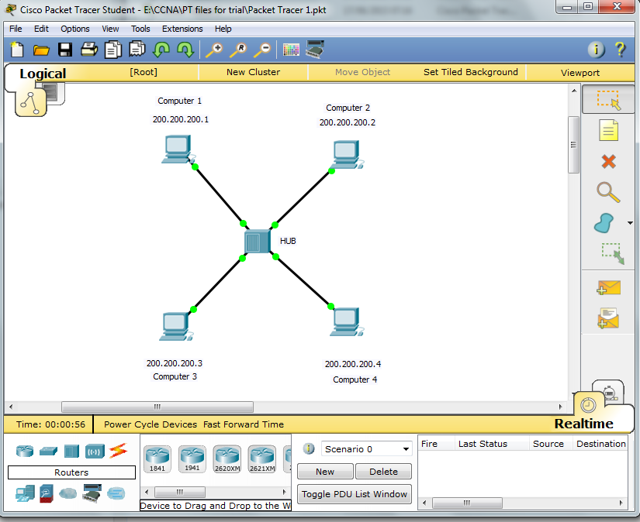

2) Packet Tracer can operate in two modes Realtime(clock ) and Simulation(stopwatch). When you opened the file as shown above Packet Tracer starts in Realtime mode. To switch over to Simulation mode click on the stopwatch tab

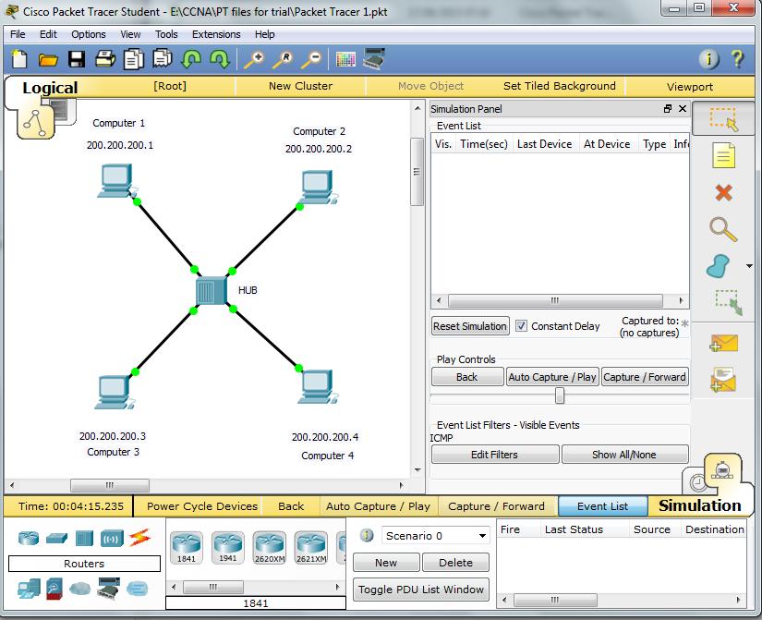

3) Now click on the closed envelope icon on the right to generate a simulated Ping signal. Click on Computer 1 (Source of the Ping) then click on Computer 4 (Destination of the Ping). An envelope will appear at computer 1 to illustrate the packet to be sent..

4) Now click on Auto Capture/Play button and watch the journey of the packet from source to destination. Once the sequence is complete (ie the packet has echoed back to the source), then click the Auto Capture button again to stop the simulation.

5) To replay click on Reset Simulation button. To change simulation for a different source/destination click the Delete button beneath Scenario 0 and repeat step 3.

6) You can vary the speed of the simulation using the slider beneath the Auto Capture/Play Button. You can also single-step the sequence by clicking on the Capture/Forward button.

***Hub Operation***

What happens to the packet when it reaches the hub?